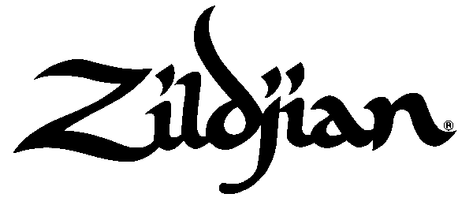
22 Longwater Drive, Norwell, MA 02061

(781) 871-2200 – Phone (877) 662-3347 - Fax
Return by e-mail to: keitha@zildjian.com

Return by fax: 781-871-3984

(attn: Keith Aleo)

Educational Clinic-Support Request Form

This form is to be completed and faxed or e-mailed to Zildjian, no less than 30 days in advance of the event. All requests received within four weeks of the proposed session will be declined. Zildjian will consider requests for support toward clinics and master-classes, but Zildjian does not provide support for performances or adjudication. It is the host's responsibility to secure all the necessary information requested within this form as well as taking responsibility for advertising and promoting the event. After Zildjian’s level of support has been determined, the host and the Artist will be notified by either return fax or e-mail. Zildjian will pay the artist directly after the event unless otherwise requested and approved. Photos from the clinic are welcomed.

General Information

Artist Requesting or Participating ___ Date Requested

Artist’s e-mail address ___ ___

Event Name Date of Event

Event Venue and Location

Event Address – to advertise the event on the Zildjian website
Event Type * Clinic Masterclass

Event description – for inclusion on the Zildjian website
___________________________________________________________________________________

Will digital and/or hard copy photos be provided to Zildjian? Yes No
(digital are best, and can be included as an attachment to an e-mail)

Zildjian cymbals for the Artist and/or event will be provided by the: Host or School Artist

Please list what Zildjian cymbals (sizes/weights) will be used:

________________________________________________________________________________________

Expected Attendance: >25 25-50 50 – 100 100 – 200 200+

* Clinic-presenter speaks/instructs/demonstrates-techniques, concepts & ideas.
* Masterclass-attendees are called to stage to receive personal instruction in front of audience.

Host Name ___ ______ Position
School or Business Address (Please no P.O. Boxes – UPS will not ship to P.O. Boxes) __

Phone___________ Fax_________ E-Mail address ____

Co-sponsorship

Host Contribution

Corporate Co-sponsor (if any) – name of company and contact person:

1)
2)

For Zildjian Use Only

Date Rec. ________Approval Date Amount By

